**Assignment 1 -** **Render a large list using SectionList**

**Overview**

So far, you have learned about the **FlatList** and **SectionList** components and how to render large lists using them. You’ve discovered that while **FlatList** is useful for rendering large lists performantly, **SectionList** adds the ability to separate list items into sections.

In this assignment, you will expand on the example from an earlier exercise to display a large list of menu items with each item’s price. You will use the **SectionList** component within the Little Lemon app.

By doing this, each menu item will be categorized according to its item type and will display section headers such as Appetizers, Main dishes and so on.

**Scenario**

The Little Lemon app needs to display a large list of menu items on the screen, along with the price of each item, sorted into sections. You have been asked to use the **SectionList** component to render these menu items efficiently. Make sure that the component you write is readable and clean.

Below is the array of menu items, along with the price for each item.

|  |
| --- |
| const menuItemsToDisplay = [  {  title: 'Appetizers',  data: [  { name: 'Hummus', price: '$5.00' },  { name: 'Moutabal', price: '$5.00' },  { name: 'Falafel', price: '$7.50' },  { name: 'Marinated Olives', price: '$5.00' },  { name: 'Kofta', price: '$5.00' },  { name: 'Eggplant Salad', price: '$8.50' },  ],  },  {  title: 'Main Dishes',  data: [  { name: 'Lentil Burger', price: '$10.00' },  { name: 'Smoked Salmon', price: '$14.00' },  { name: 'Kofta Burger', price: '$11.00' },  { name: 'Turkish Kebab', price: '$15.50' },  ],  },  {  title: 'Sides',  data: [  { name: 'Fries', price: '$3.00', id: '11K' },  { name: 'Buttered Rice', price: '$3.00' },  { name: 'Bread Sticks', price: '$3.00' },  { name: 'Pita Pocket', price: '$3.00' },  { name: 'Lentil Soup', price: '$3.75' },  { name: 'Greek Salad', price: '$6.00' },  { name: 'Rice Pilaf', price: '$4.00' },  ],  },  {  title: 'Desserts',  data: [  { name: 'Baklava', price: '$3.00' },  { name: 'Tartufo', price: '$3.00' },  { name: 'Tiramisu', price: '$5.00' },  { name: 'Panna Cotta', price: '$5.00' },  ],  },  ]; |

Use this array to render the items within the screen.

The screenshots below illustrate how your app should look after you complete this assignment: 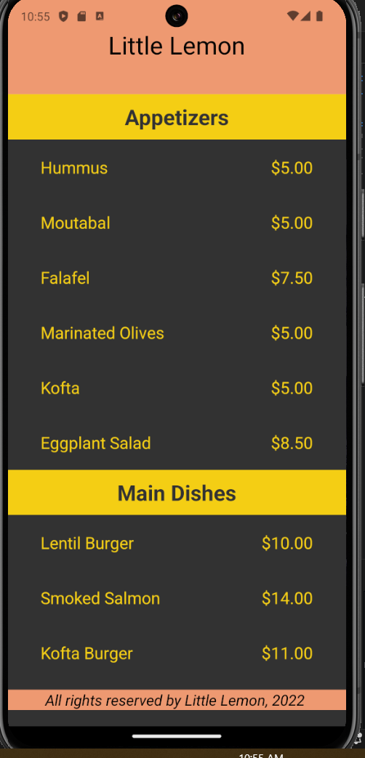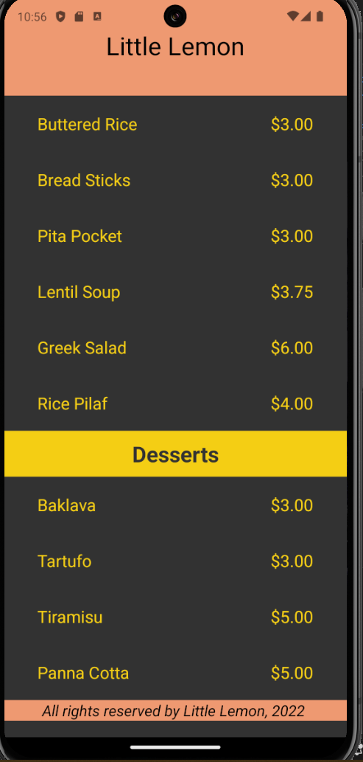

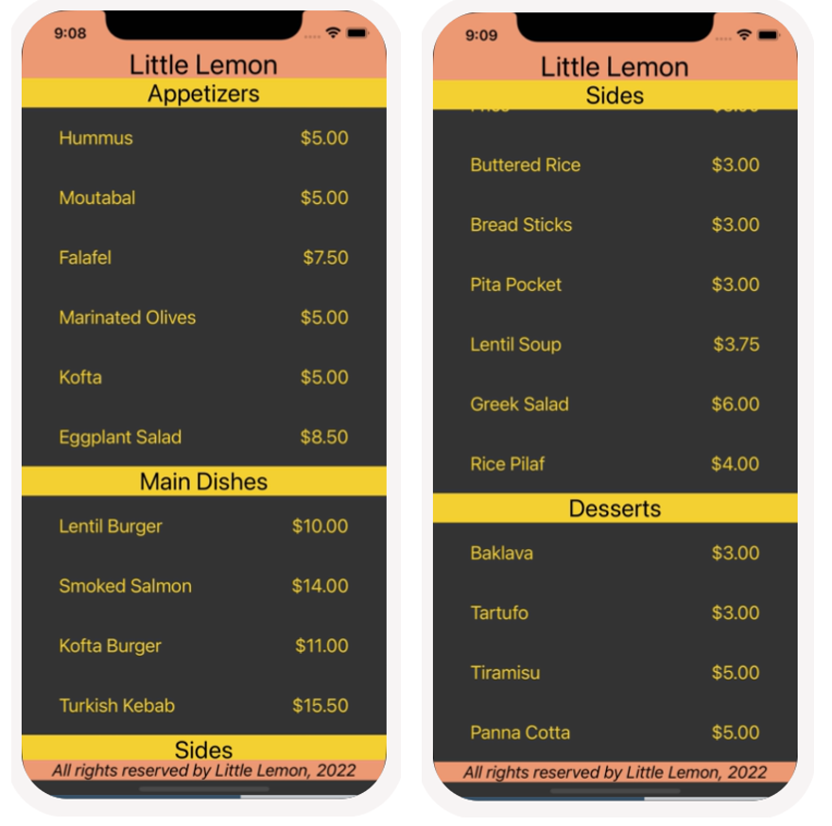

The colors displayed in the images above can be applied using the following values:

*#F4CE14, #EE9972, #333333, #*EDEFEE, *black* and *white.*

**Starter Code:**

You can download the starter code for this assignment, from the zipped folder below:

<1_sectionlist---starter-code.zip>

**Instructions**

### Step 1: Update MenuItems component to display new list of menu items and use SectionList

To complete this assignment, you’ll first need to update the **MenuItems** component to display the menu items and price.

Within this component, use the array provided in this scenario to pass to the **data** prop of the **SectionList** component. Then configure the **renderItem** prop of the **SectionList** component to render each item’s name as well as the price per item.

**Hint**: You can create multiple components within the same file to keep code clean.

### Step 2: Render Section Header

In this step, you will use the **SectionList** component to render the section header. The headers are provided within the **title** property in the array **menuItemsToDisplay**. Utilize it to render the headers for each section of menu items. Make sure that each menu item is now displayed inside the appropriate section.

### Step 3: Style the component

In this step, you will style the new component that you have created to match the screenshots. Make sure to provide meaningful names to all your styles.

## **Conclusion**

By completing this assignment, you will demonstrate your understanding and ability to configure and utilize the **SectionList** component to render a large list of items by section.